Payroll Management System for Information Technology Company

Version 1.0

Revision History

|  |  |  |  |
| --- | --- | --- | --- |
| **Date** | **Version** | **Description** | **Author** |
| 15/12/2019 | 1.0 | Final | Quản Trọng Tú |
|  |  |  |  |
|  |  |  |  |
|  |  |  |  |

Table of Contents

1. Use-Case Name 4

1.1 Brief Description 4

1.2 Actor 4

2. Flow of Events 4

2.1 Basic Flow 4

3. Special Requirements 4

4. Preconditions 5

5. Postconditions 5

6. Extension Points 5

# Use-Case Name

## Brief Description

This use case defines the step of viewing all user working time. Employee can easily view all user Leave information to have an overview.

## Actor

Employee

# Flow of Events

## Basic Flow

Employee click View All button to show all user Leaves information. If it is null it will show message and if it is empty, table won’t display anything.

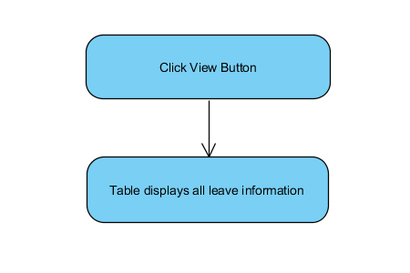

Basic flow of Viewing all user Leave information.

# Special Requirements

No special requirements.

# Preconditions

* Employee have to login into this application and access Manage Leave view.

# Postconditions

* Table displays all leave information.

# Extension Points

No Extension Points.